User Guide for
NCP81075
Evaluation Board

This user guide is intended to assist those using the NCP81075 Evaluation Board. It will provide useful tips and procedures for powering up and using the Evaluation Board (EVB). It is intended as a quick-start guide rather than a comprehensive manual.
Description
The NCP81075 is a high performance dual MOSFET gate driver optimized to drive the gates of both high and low side power MOSFETs in a synchronous buck converter. The NCP81075 uses an on−chip bootstrap diode to eliminate the external discrete diode. A high floating top driver design can accommodate HB voltage as high as 180 V. The low−side and high−side are independently controlled and match to 4 ns between the turn−on and turn−off of each other. Independent Under−Voltage lockout is provided for the high side and low side driver forcing the output low when the drive voltage is below a specific threshold.
Features
- Drives Two N-Channel MOSFETs in High-Side and Low-Side Configuration
- Floating Top Driver Accommodates Boost Voltage up to 180 V
- Switching Frequency up to 1 MHz
- 20 ns Propagation Delay Times
- 4 A Sink, 4 A Source Output Currents
- 8 ns Rise / 7 ns Fall Times with 1000 pF Load
- UVLO Protection
- Specified from −40°C to 140°C
- Offered in SOIC−8 (D), DFN8 (MN), WDFN10 (MT) Packages
Quick Start Connection Guide
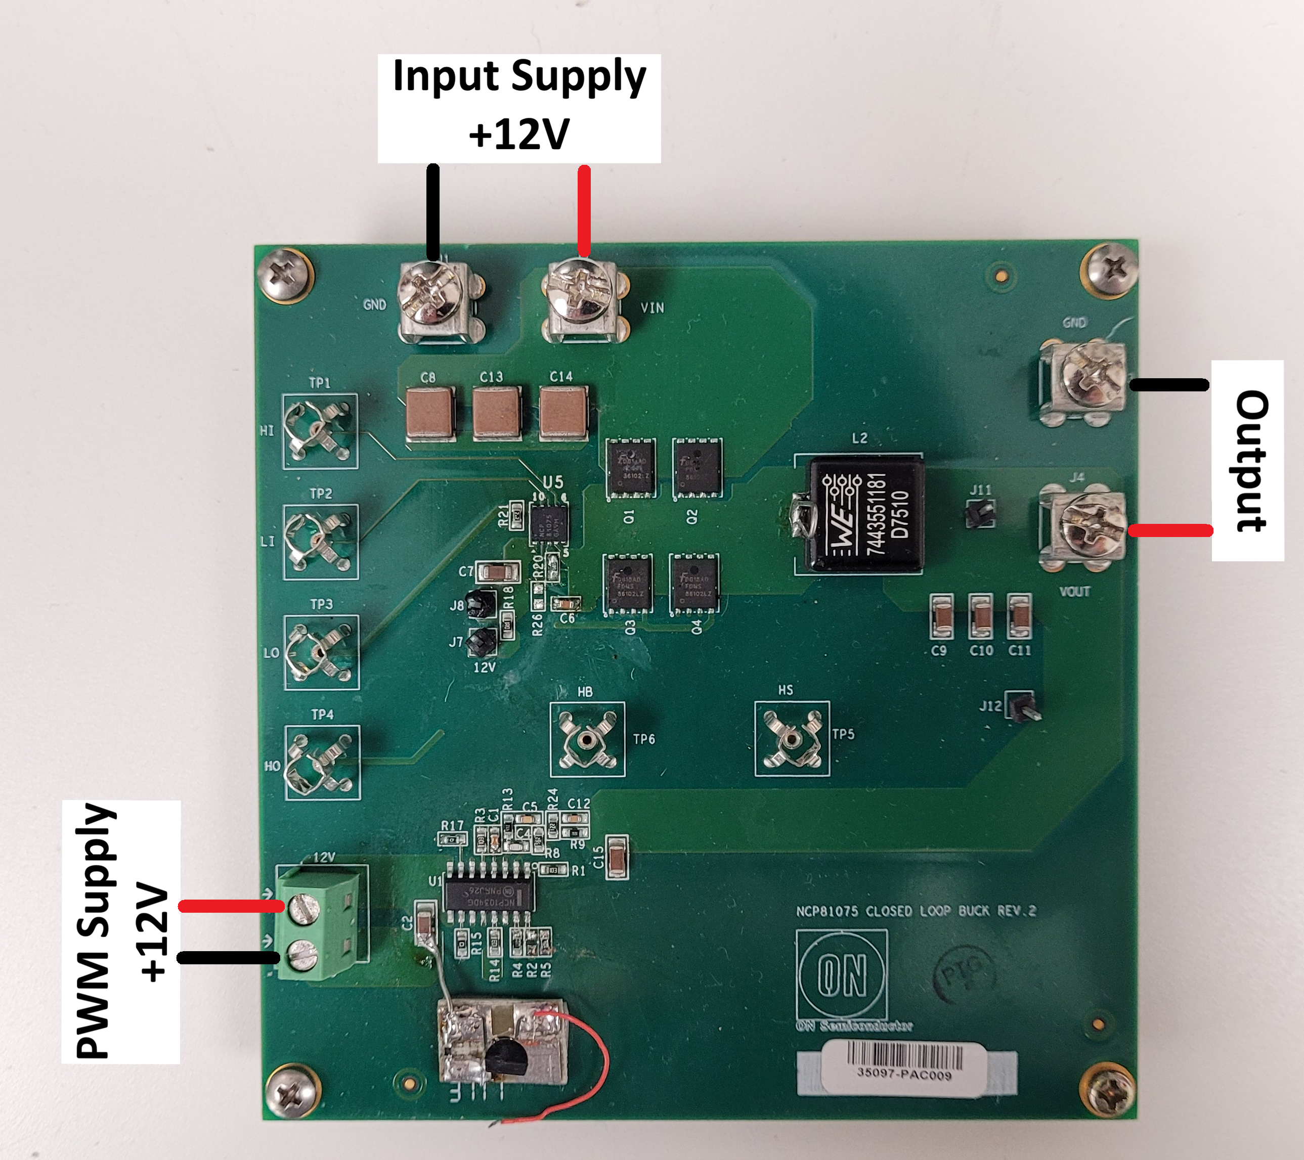

Connect a power supply capable of 20V and 5A+ to the Input Supply connector (+ to VIN, - to GND), set the input supply voltage to 12V and the current limit to 1A. Connect another power supply capable of 20V and 5A+ to the “12V” voltage connector for the PWM Supply, set the input supply voltage to 12V and the current limit to 1A. Turn on both supply, measure Output voltage.

